

**COMPLETE PROJECT REPORT**

**Funding Scheme :** Endowment Fund for Research & Development

**Project Title :** Research on AI-Powered Institutional Superintendence System

**Project Code :** 2022-23/EFRD/RP/CSE/01

**Name of the PI :** Dr. N. BALAJI,  
 D.C.T., B.Tech.,M.E.,Ph.D..  
 Professor and Head  
 Department of computer science & Engineering



Date : 23/12/2022

**Submitted to :** The Principal

**Through :** R&D Cell

**Subject :** Requisition of Fund for a Research Project-reg.

Respected Sir,

With reference to the circular dated 20/12/2022, I hereby expressing my interest in doing a research project entitled, "Research on AI-Powered Institutional Superintendence System" for the purpose of facilitating the ease of faculty work and streamlining class attendance, mark lists, and profiles. I request a financial support of Rs. 1,70,000/- (One Lakh Seventy Thousand rupees Only) for the implementation of the project and enclosing the detailed project proposal with this for your kind perusal.

Thanking you,

Yours sincerely,

Dr. N. BALAJI,  
 D.C.T., B.Tech.,M.E.,Ph.D..  
 Professor and Head  
 Department of computer science & Engineering



**PROJECT PROPOSAL**

**Funding Scheme :** Endowment Fund for Research & Development

**Title of the Project :** Research on AI-Powered Institutional Superintendence System

**Name of the PI :** Dr. N. BALAJI

**Designation & Dept. :** Professor and Head  
 Department of computer science & Engineering

**Name of the Co-PI :** Mrs.K.Andal, Assistant Professor Department of computer science & Engineering

**Details of the Project Team:**

* + - * 1. Mr.Ajay S (CSE - IV Year)
        2. Mrs.Arul Jenifer A (CSE - IV Year)
        3. Mr.Thiruvarasan M (CSE - IV Year)
        4. Mr.Shiyam M (CSE - IV Year)

**Abstract :**

The "Research on AI-Powered Institutional Superintendence" project aims to modernize educational management systems by introducing automated attendance tracking and student mark list generation. Traditional methods are often time-consuming and prone to errors, lacking real-time insights. Our system will utilize various technologies such as responsive application to ensure accurate attendance recording, seamlessly integrating with existing databases.

Advanced algorithms will analyze attendance data, providing administrators with instant metrics and enabling proactive intervention for attendance-related issues. Additionally, the system will automate mark list creation, reducing administrative burdens for educators and offering customizable templates to suit specific requirements. Benefits of the project include streamlined administrative processes, improved data accuracy, and timely interventions to enhance student attendance and academic performance.

In summary, by introducing modern technologies, institutions can optimize their operations, enhance outcomes, and contribute to educational innovation.

**Project Plan :**

|  |  |  |  |
| --- | --- | --- | --- |
| Work to be done | Period in day/months | Expected Fund in Rs. | List of Equipment required for the project and any other support |
| Student & Faculty Profile | 20 days | Rs.40,000.00 | 1. Furniture 2. Projector with Screen 3. System 4. Server 5. Domain |
| Attendance | 1 month 15 days | Rs.61,000.00 |
| Result Analysis | 20 days | Rs.60,500.00 |
| Integration | 5 days | Rs.8,500.00 |
| Total Expected Fund | | Rs.1,70,000/- (One Lakh Seventy Thousand Only) | |

**Signature of the PI**

Dr. N. BALAJI,  
 D.C.T., B.Tech.,M.E.,Ph.D..  
 Professor and Head  
 Department of computer science & Engineering



**FUND UTILIZATION REPORT**

**Funding Scheme :** Endowment Fund for Research & Development

**Project Code :** 2022-23/EFRD/RP/CSE/01

**Title of the Project :** Research on AI-Powered Institutional Superintendence System

**Name of the PI :** Dr. N. BALAJI

**Designation & Dept. :** Professor and Head  
 Department of computer science & Engineering

**Name of the Co-PI :** Mrs.K.Andal, Assistant Professor Department of computer science & Engineering

**Details of the Project Team:**

1. Mr.Ajay S (CSE - IV Year)
2. Mrs.Arul Jenifer A (CSE - IV Year)
3. Mr.Thiruvarasan M (CSE - IV Year)
4. Mr.Shiyam M (CSE - IV Year)

It is reported that a sum of Rs. 1,70,000/- (One Lakh Seventy Thousand rupees Only) sanctioned by Sri Venkateshwaraa College of Engineering & Technology under the Funding Scheme of "Endowment Fund for Research & Development" for carrying out the project, "Research on AI-Powered Institutional Superintendence System" has been utilized for which it was sanctioned and sum of Rs. 1,70,000/- (One Lakh Seventy Thousand rupees Only) remained unutilized has been refunded.

**Enclosure:** **Outcome of the Project**

The AI-powered system automates attendance tracking, freeing faculty for teaching, ensuring accuracy, and providing real-time insights for proactive interventions. Students' access to attendance data promotes engagement, while streamlined administrative processes reduce burdens, enhancing overall effectiveness.

PI R&D Cell HOD PRINCIPAL



**PROJECT OUTCOME**

**Funding Scheme :** Endowment Fund for Research & Development

**Project Code :** 2022-23/EFRD/RP/CSE/01

**Title of the Project :** Research on AI-Powered Institutional Superintendence System

**Name of the PI :** Dr. N. BALAJI

**Designation & Dept. :** Professor and Head  
 Department of computer science & Engineering

**Outcome of the Project :**

**Problem:**

Educational institutions face challenges with manual attendance tracking systems, which are time-consuming, error-prone, and lack real-time insights. Additionally, the process of creating student mark lists is labor-intensive, leading to inefficiencies and administrative burdens for educators. These issues hinder the effective management of student attendance and academic records.

**Solution:**

The "Research on AI-Powered Institutional Superintendence" project introduces an automated system utilizing responsive web applications for seamless and accurate attendance tracking, without biometric scans or RFID tags. Advanced algorithms provide real-time metrics and enable proactive interventions for attendance issues. Additionally, the system automates student mark list creation, reducing administrative burdens and enhancing efficiency.

**Implementation:**

The implementation of the proposed system will involve the development of a user-friendly web application for both students and faculty members. The application will allow students to check-in to classes using their smartphones, while faculty members can easily record attendance and access attendance reports. The system will be integrated with existing institutional databases to ensure data accuracy and compatibility. Additionally, customizable templates will be provided for mark list generation, allowing institutions to tailor the format according to their specific requirements.

**Output:**

**Profile**

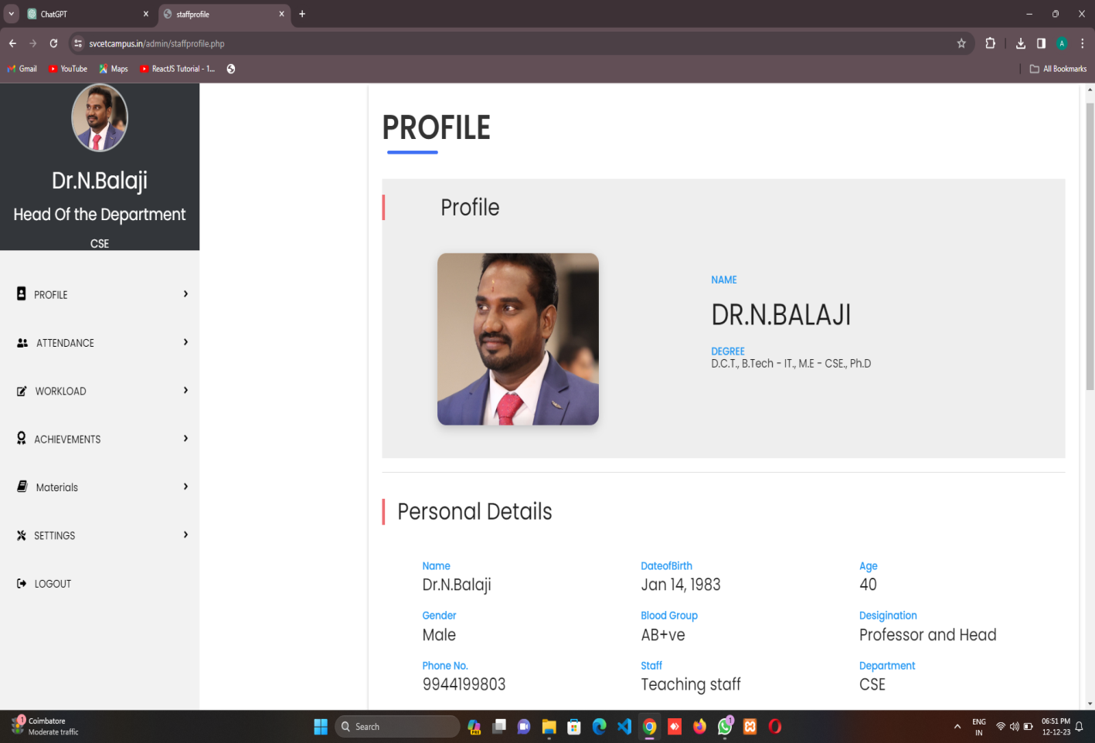

**Attendance & Leave Request**

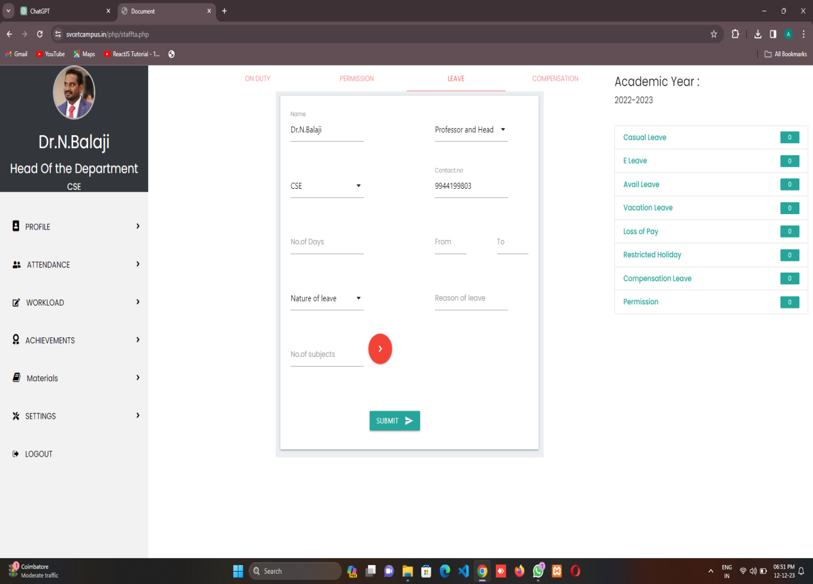

**Result Analysis**

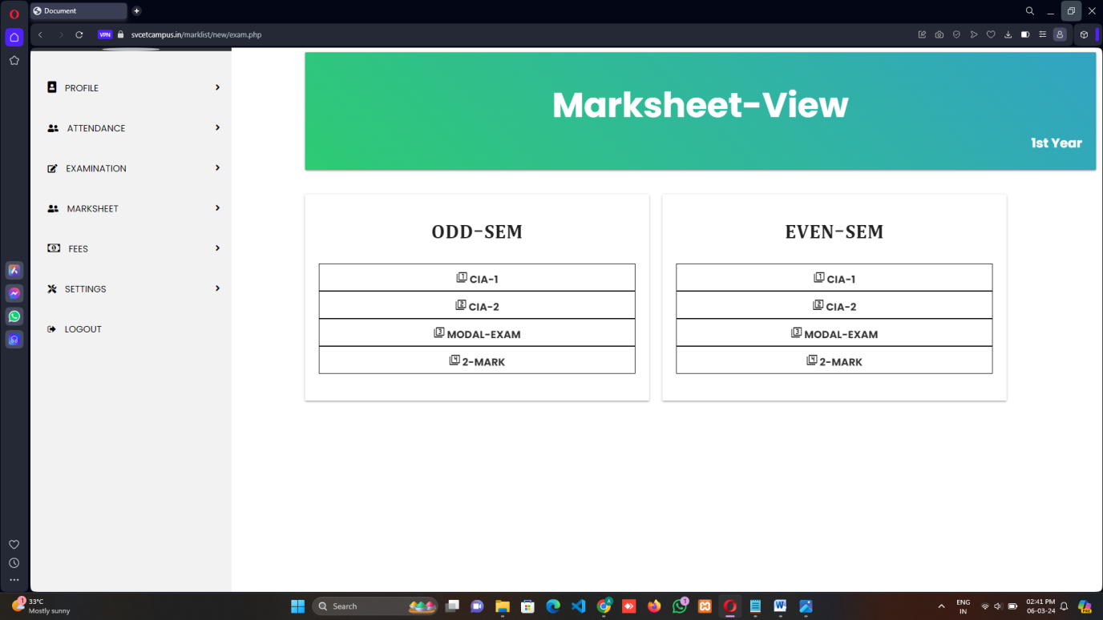

**Outcome:**

The implementation of the AI-powered institutional superintendence system will yield several positive outcomes for educational institutions. Firstly, it will streamline administrative processes, reducing the time and effort required for attendance tracking and mark list generation. Secondly, it will improve data accuracy and integrity, minimizing errors associated with manual data entry. Thirdly, it will enable timely interventions to address attendance-related issues and improve student outcomes. Overall, the system will enhance operational efficiency, transparency, and accountability within educational institutions, paving the way for greater success and innovation.

**Signature of the PI**

Dr. N. BALAJI,  
 D.C.T., B.Tech.,M.E.,Ph.D..  
 Professor and Head  
 Department of computer science & Engineering